**EDUCATION**

_________________________________________________

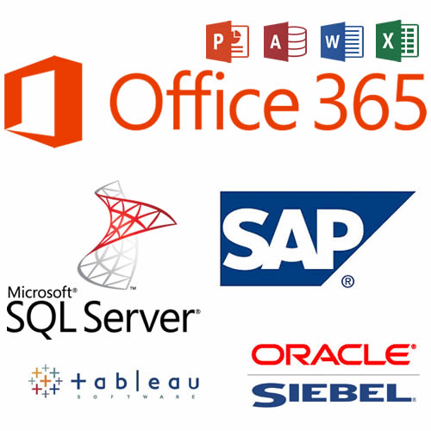

**MY EXPERTISE**

_________________________________________________

**PERSONAL STATEMENT**

_________________________________________________

I'm an experienced **Senior Financial and Business Analyst** based in Atlanta, GA. My work is always of the highest quality; I take on each assignment as though it were my own. My expertise includes, but is not limited to Microsoft Office Suite (Office 365), SQL Server, Relational Database Management Systems, Siebel, Tableau, and SAP.

I’m punctual, creative, and responsible. I work well with management, peers, and clients from all backgrounds. I am a consummate perfectionist at everything I do; I refuse to fail. I’m a perpetual learner; I’m always looking for new, more efficient ways of accomplishing tasks.

While I’ve enjoyed the freelance world, I am looking forward to permanently returning to the workforce to add value and achieve additional personal goals.

**BACHELOR OF ARTS IN BUSINESS ADMINISTRATION**

***Concentration in Finance***

CLARK ATLANTA UNIVERSITY

**RECOGNITIONS**

_________________________________________________

Analyst of the Year (2013) LeasePlan USA Internal contest (project based) |Alpharetta, GA $1,300 Payroll bonus

**HOBBIES**

_________________________________________________

**Additional Expertise…**

_________________________________________________

Web Development/Design

**Portfolio Link:**

[**https://atlantawebdesignsolutions.com**](https://atlantawebdesignsolutions.com)

***Experience includes*** *HTML5, CSS3, PHP, Javascript, jQuery, SQL, XML, JSON, AJAX*

Intuit, Domo, Infusionsoft, Adobe Catalyst, Survey Monkey, SQL, MySQL, PowerPivot

**CAREER EXPERIENCE**

_________________________________________________

**Freelance Business Analyst (present job)**

+ **Develop analytical models** for search **marketing** clients

+ Design database tables and construct SQL queries for data extraction

**LeasePlan U.S.A.** From February 2012 to July 2014

**Sr. Procurement Analyst (2012-2013)**

+ Acted as a **liaison** between the company, finance department, and our vendors

+ Helped to **establish** and adhere to certain **purchasing guidelines** based on the strategies and goals outlined by LeasePlan and more specifically the finance department.

+ Regularly **composed RFI’s** (Request for Information) in order to invite service and merchandise suppliers to bid on projects.

+ **Negotiated the exact terms** of the agreement so as to establish clear expectations on the part of both parties.

+ Designed database tables and construct SQL queries for data extraction

**Comcast** From March 2011 to February 2012

**COORD 2, TECHNL PRODT SALES SPT**

+ Performed order entry as required and coordinated the resolution of order discrepancies directly with third party entities and customers both internal and external.

+ Provides comprehensive order and day of install support including date reconciliation, static IP support, billing/provisioning codes, split orders, reschedules, toll free fallout, directory listing fallout, LNP fallout, NPAC/ NPS task completions, customer escalations, validation and correction of any revenue impacting discrepancies and coordination of Tech dispatches.

**AT&T** From November 2004 to December 2010

**Retention Specialist (CSR 2004-2007) ; Financial Analyst (2008-2010)**

+ Provided bookkeeping service, liaising with the accountant and auditor as required

+ Provided regular management information reports for the Regional Executive Board

+ Supported the development of projects with budgeting and financial plans